

**Cars and Climate Change**

**Grade:** 10th

**Objective:** This activity will educate students on the emissions and overall pollution associated with cars and society’s approach to transportation.

**Key Terms:**

Carpooling

Emissions

Carbon Dioxide

Pollution

Greenhouse Gas

**Materials:**

Paper/pencil

Handout

Street view

**Introduction:**

Hold the activity during pick-up time or identify a nearby street with regular vehicle traffic and with a safe location, such as a sidewalk, for students to stand and observe traffic. Review mean, median, and mode with your class or introduce them to the concepts, using the car observation data.

**Questions:**

1. How can carpooling reduce air pollution?

2. What can students do to help reduce car travel and air pollution?

3. Did you see cars idling? If so, why could this be bad for air pollution?

4. What can teachers and school staff do to help reduce car travel and air pollution?

5. On the back side, draw a design for a logo or symbol to remind the school or the community to drive less. For example, the logo could be a symbol for walking more and driving less.

**Procedure:**

1. As a group, count the number of cars you see in fifteen minutes. Complete the chart below. In the first column, tally the number of cars you see with one, two, three, four, or five people inside after they have picked up the kindergartener(s). Later, in the second column, multiply the tallied number of cars by the number of people in those cars.

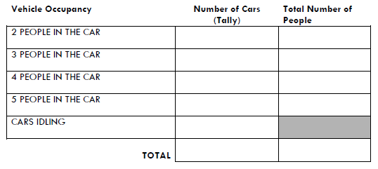

1. How many cars were idling while waiting for Kindergarteners to come out?
2. Find the average number of people in a car at your school by dividing the total number of people in the cars by the total number of cars:

Average number of people in a car:

1. Now, calculate the median number of people in the cars. Write down the number of people in each car from fewest to most, and then find the middle number. For example, if you saw four 1-person cars, two 2-people cars, and one 3-people car, those seven numbers in order would look like this: 1, 1, 1, 1, 2, 2, 3. The middle number is the fourth number, which is 1. If there is an even number of cars, add the two middle numbers and divide the total by two.

Median number of people in a car:

1. Finally, calculate the mode number of people in the cars. The mode is the number that appears the most often. To find the mode, look at the row of numbers of passengers, and count how many times each number appears. The number that appears the most often is the mode. In the example above, 1 appears most often.

Mode number of people in a car: